04 JOINTS AND SET OPERATIONS

PART 1: CROSS JOIN
STEP 1: CREATE TABLES
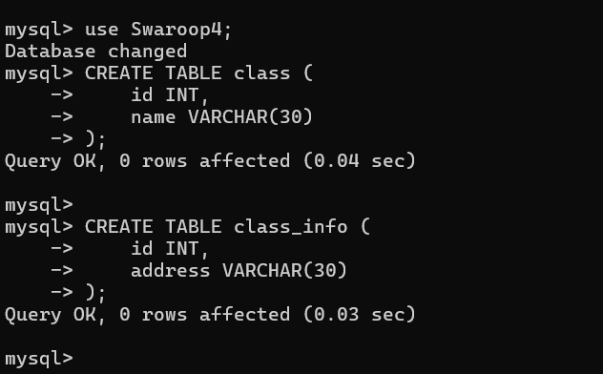

STEP 2: INSERT DATA
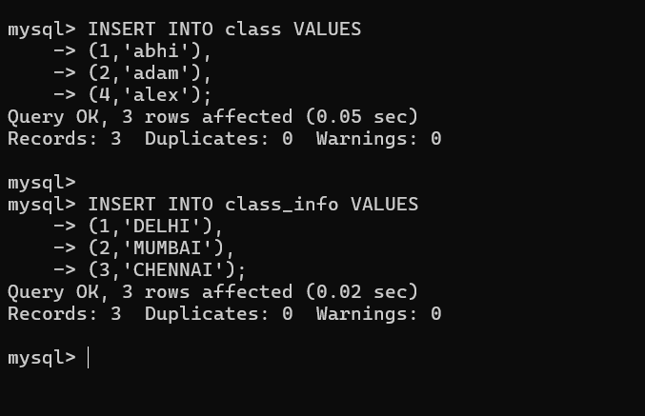

QUESTION 1 - CROSS JOIN
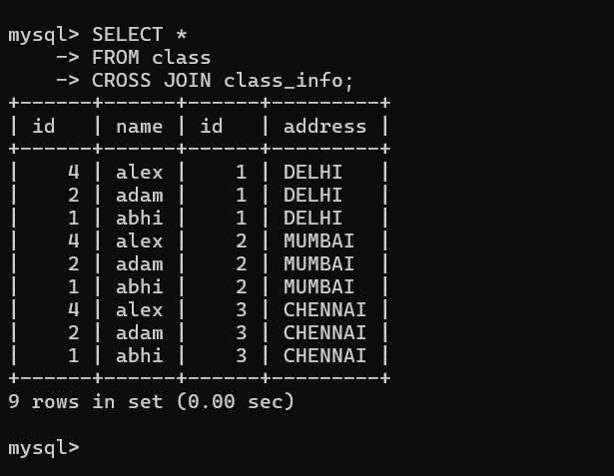

PART 2: INNER JOIN
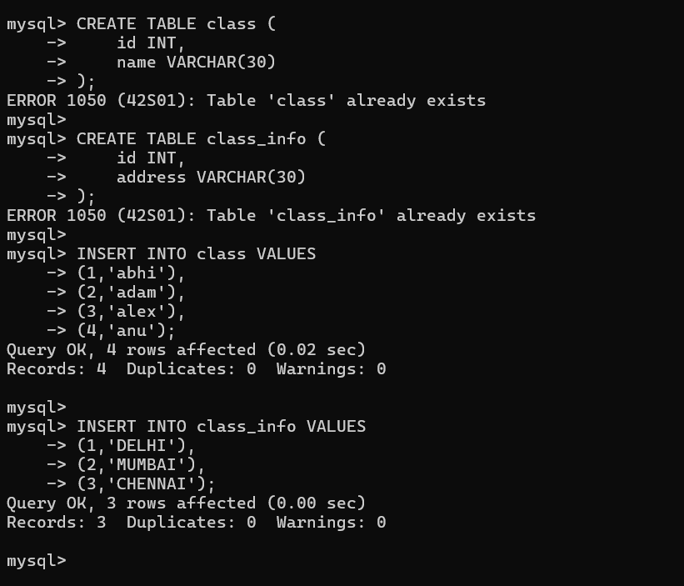

QUESTION 2 - INNER JOIN
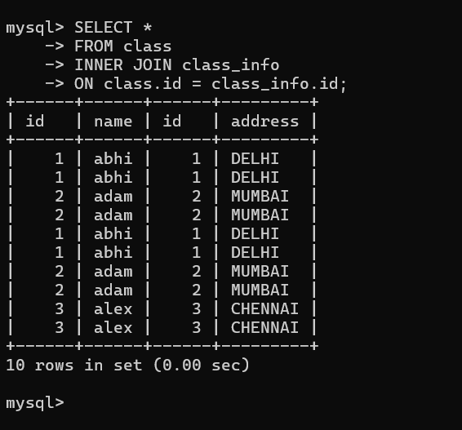

QUESTION 3 - INNER JOIN
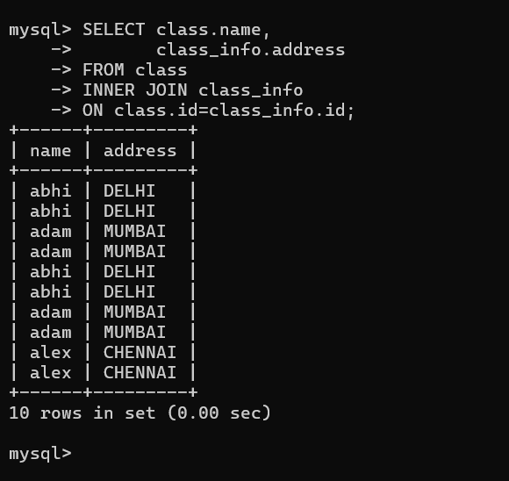

PART 3: NATURAL JOIN
QUESTION 4 - NATURAL JOIN
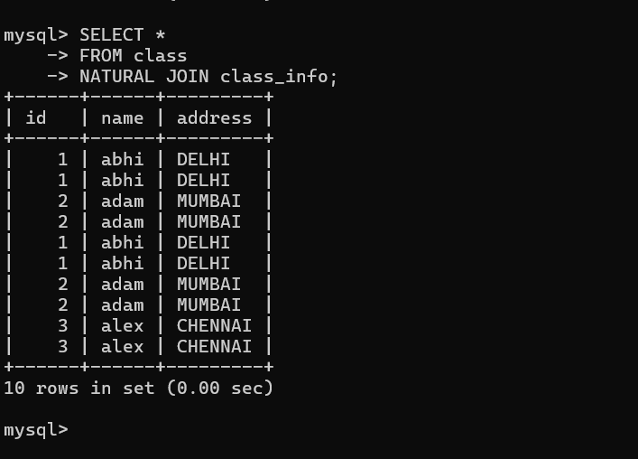

PART 4: LEFT OUTER JOIN
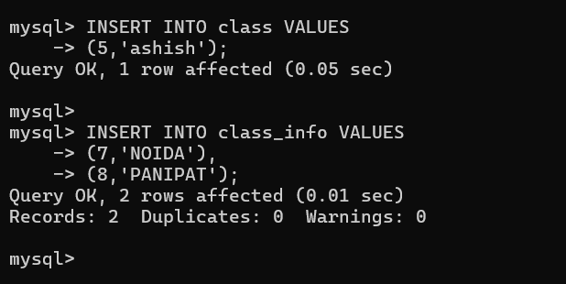

QUESTION 5 - LEFT JOIN
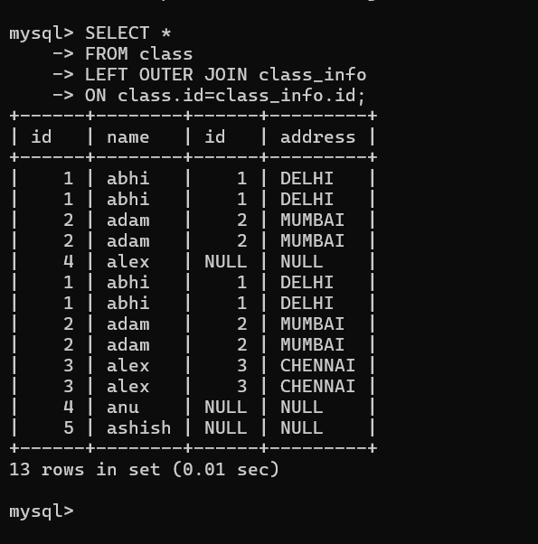

QUESTION 6 - LEFT JOIN
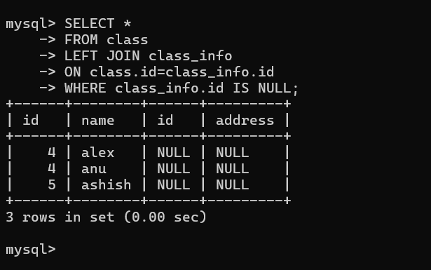

PART 5: RIGHT OUTER JOIN

QUESTION 7 - RIGHT JOIN
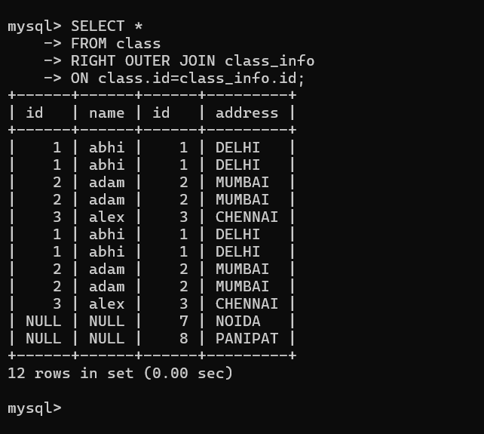

QUESTION 8 - RIGHT JOIN
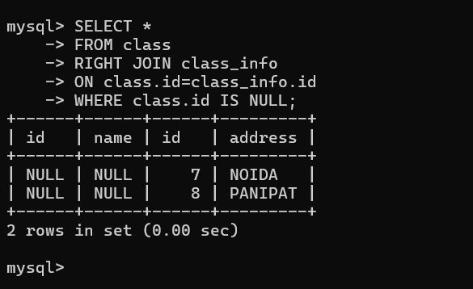

PART 6: FULL OUTER JOIN
QUESTION 9 - FULL OUTER JOIN
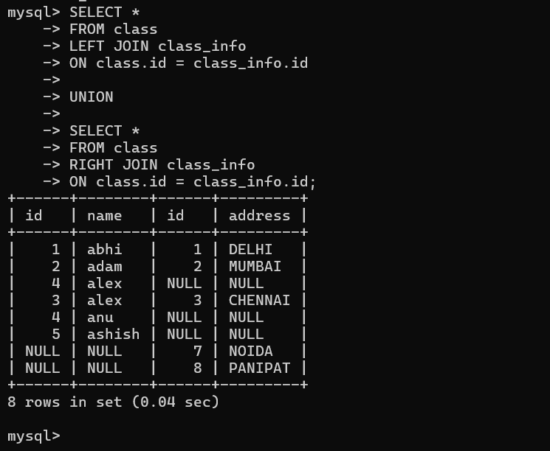

QUESTION 10 - FULL OUTER JOIN
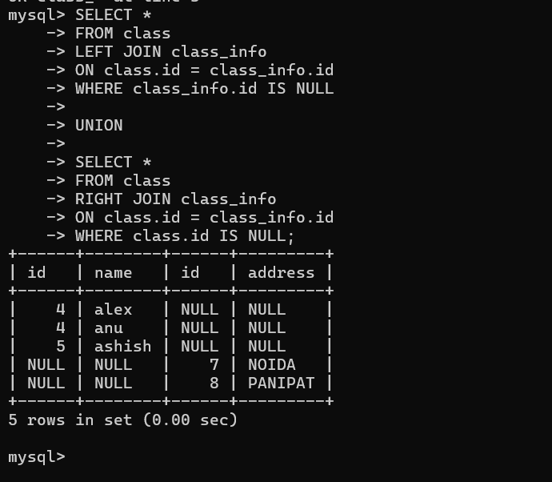

PART 7: UNION
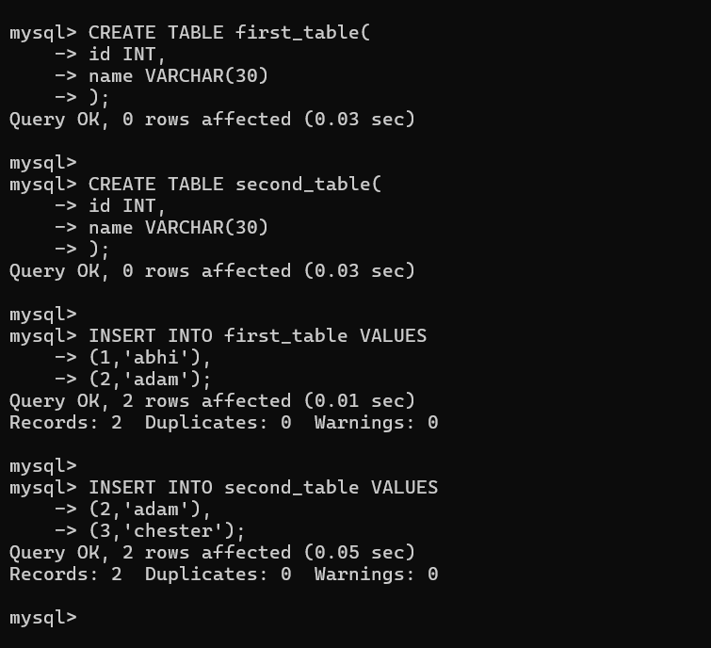

QUESTION 11 – UNION
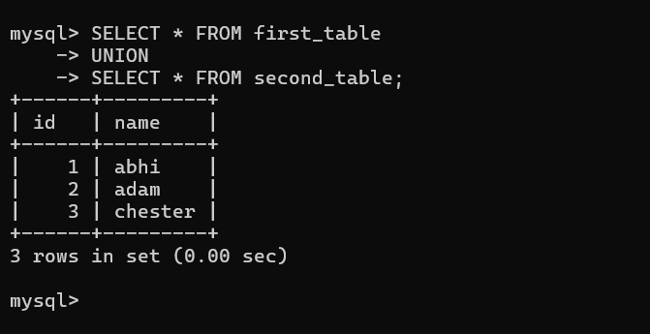

QUESTION 12 – UNION
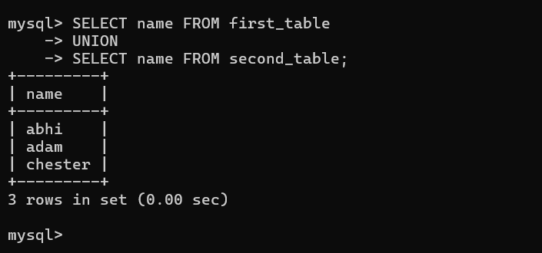

PART 8: UNION ALL
QUESTION 13 - UNION ALL
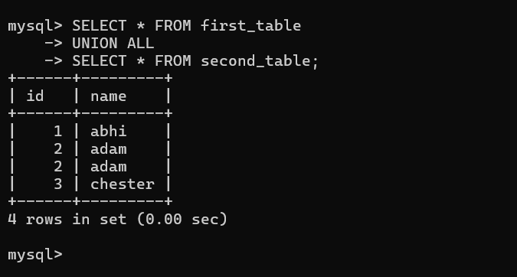

QUESTION 14 - UNION ALL
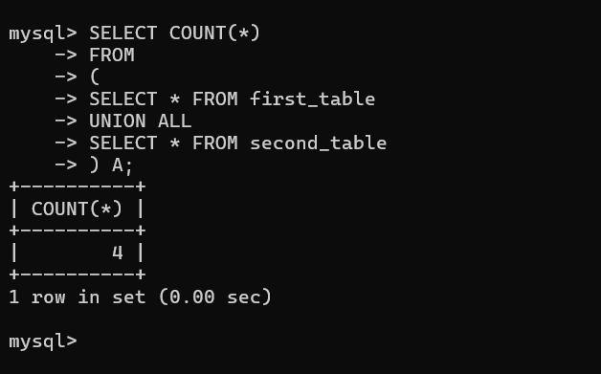

PART 9: INTERSECT
QUESTION 15 – INTERSECT
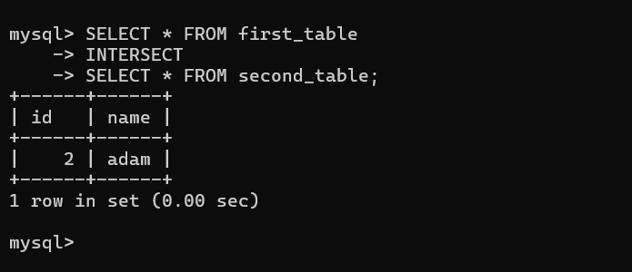

QUESTION 16 – INTERSECT
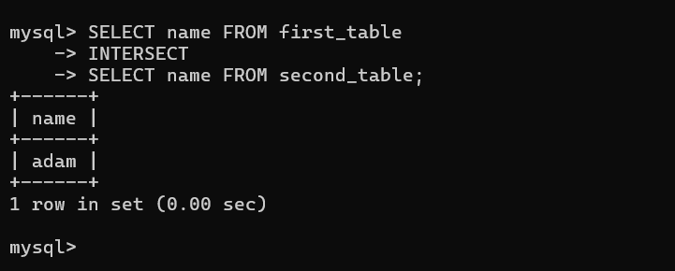

PART 10: MINUS
QUESTION 17 – MINUS
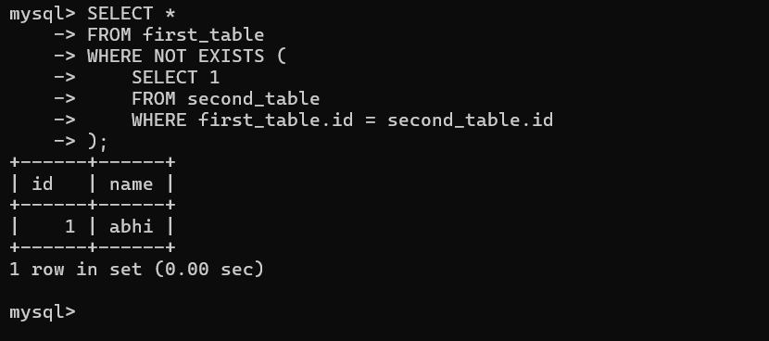

QUESTION 18 – MINUS
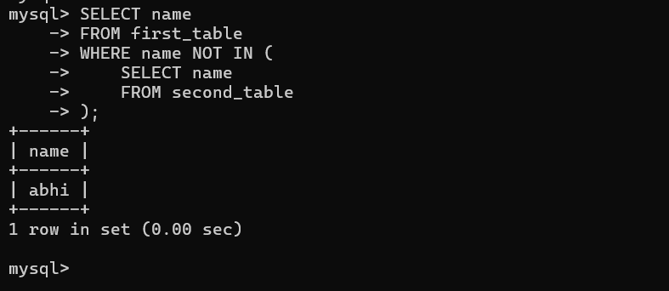

ADVANCED INTERVIEW QUESTIONS
QUESTION 19
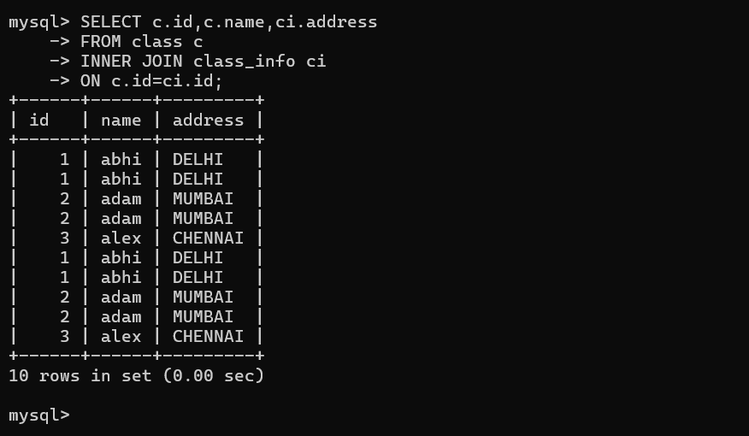

QUESTION 20
